Gas leakage monitoring and alerting system

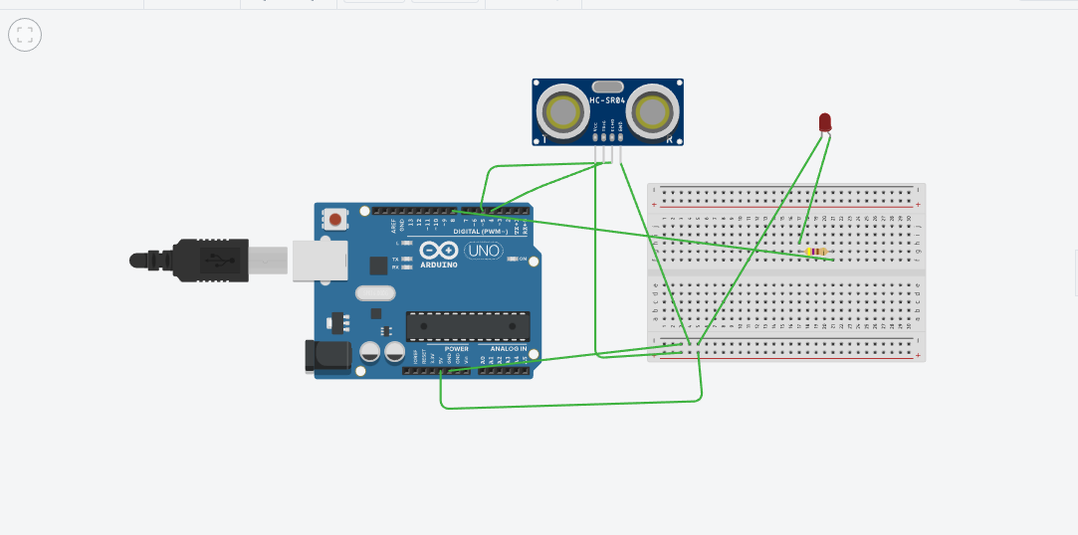

Code

#define trigPin 4

#define echoPin 5

long duration;

int distance;

const int redPin = 8;

void setup(){

pinMode(trigPin, OUTPUT);

pinMode(echoPin, INPUT);

pinMode(redPin, OUTPUT);

Serial.begin(9600);

}

void loop(){

digitalWrite(trigPin, LOW);

delayMicroseconds(2);

digitalWrite(trigPin, HIGH);

delayMicroseconds(10);

digitalWrite(trigPin, LOW);

duration = pulseIn(echoPin, HIGH);

distance = duration \* 0.034 / 2;

delay(2000);

Serial.print("Distance: ");

Serial.print(distance);

Serial.println(" cm");

if(distance <= 15){

digitalWrite(redPin,255);

Serial.println("ON");

}

else{

digitalWrite(redPin,127);

Serial.println("OFF");

}

}